IHS Patient and Family Education Protocols/Codes
Goals and Objectives
The purpose of this presentation is to increase awareness of the importance of using the IHS standardized method for documentation and coding of Patient Education

This handout will also demonstrate the role of tracking patient education in key areas:
  - JCAHO/CMS – Joint Commission on Accreditation of Healthcare Organizations
  - GPRA – Government Performance and Results Act
  - CRS – Clinical Report System

JCAHO: The Provision of Care (PC) treatment and services is composed of 4 care components:
  - Assessing the patient needs
  - Planning for the patient needs
  - Providing for the patient’s needs
  - Coordinating the care, treatment, and services for the patient

Specific JCAHO Standards

Provision of Care, Treatment, and Services

The Hospital assesses the patient who may be a victim of possible abuse and neglect:
- Abuse and Neglect
- Sexual Abuse
DVV - DOMESTIC VIOLENCE
VICTIM
DVV-CComplications
DVV-CULCultural/Spiritual
Aspects of Health
DVV-DPDisease Process
DVV-FUFollow-up
DVV-IRInformation & Referral
DVV-LLiterature
DVV-PPrevention
DVV-PSYPsychotherapy
DVV-SSafety
DVV-SCRScreening
DVV-SMStress Management
DVV-TXTreatment

DVP - DOMESTIC VIOLENCE
PERPETRATOR
DVP-CULCultural/Spiritual
Aspects of Health
DVP-DPDisease Process
DVP-FUFollow-up
DVP-IR Information & Referral
DVP-LLiterature
DVP-PPrevention
DVP-PSYPsychotherapy
DVP-SSafety
DVP-SCRScreening
DVP-SMStress Management
DVP-TXTreatment

ABNG—Abuse and Neglect (child or elder)
ABNG-CMCase Management
ABNG-CComplications
ABNG-CULCultural/Spiritual
Aspects of Health
ABNG-FUFollow-up
ABNG-IRInformation & Referral
ABNG-LLiterature
ABNG-PPrevention
ABNG-PSYPsychotherapy
ABNG-RIPatient Rights and
Responsibilities
ABNG-RPMandatory Reporting
ABNG-SSafety

The hospital provides patient education and training on each patient’s needs and abilities. The hospital performs a learning needs assessment for each patient, which includes the patient’s cultural and religions beliefs, emotional barriers, desire and motivation to learn physical or cognitive limitations, and barriers to communications. (PC.02.03.01)

CULTURAL/SPIRITUAL ASPECTS Of HEALTH (CUL): CUL is to be used to document education/counseling that reflects an integration of the impact and influences that cultural and spiritual traditions, practices, and beliefs have on health and wellness.
Specific JCAHO Standards Continued
For patients who are receiving end-of-life care, the social, spiritual and cultural variables that influence the patient’s and family members perception of grief
Griefgrief
GRIEF-CComplications
GRIEF-CMCase Management
GRIEF-CULCultural/Spiritual Aspects of Health
GRIEF-DPDisease Process
GRIEF-EXExercise
GRIEF-FUFollow-up
GRIEF-HPDPHealth Promotion, Disease Prevention
GRIEF-IRInformation and Referral
GRIEF-LLiterature
GRIEF-MMedications
GRIEF-PSYPsychotherapy
GRIEF-SMStress Management
GRIEF-TLHTele-Health
GRIEF-TXTreatment
EOL - END OF LIFE
EOL-ADVAdvance Directive
EOL-CULCultural/Spiritual Aspects of
Health
EOL-DPDisease Process
EOL-EQEquipment
EOL-GPGrieving Process
EOL-LLiterature
EOL-LALifestyle Adaptations
EOL-MMedications
EOL-MNTMedical Nutrition Therapy
EOL-NNutrition
EOL-PMPain Management
EOL-PSYPsychotherapy
EOL-SMStress Management
EOL-TXTreatment
- Patient education and training is provided by all disciplines
- The patient’s education and training is based on his/her assessed needs.
- The patient’s ethnic and cultural factors are assessed
- The patient’s communications skills are assessed
- The patient’s emotional issues are assessed
- Visual-motor functioning is assessed

Educational Assessments
BAR - Barriers to Learning
-Blind
-Cognitive Impairment
-Deaf
-Dementia
-Does Not Read English
-Doesn’t Speak English/Interpreter Neede
-Emotional Stressors
-Fine Motor Skills Deficit
-Low Literacy
-Speaks English As a Second Language
-Hard of Hearing
-No Barriers
-Social/Emotional Stressors
-Values/Belief
-Visually Impaired
LP - Learning Preference
-Small Group
-Read
-Media
-Talk
-Do/Practice
RL - Readiness to Learn
-Distraction
-Eager
-Receptive
-Pain
-Severity of Illness
-Not Ready
-Unreceptive
-Intoxication
Specific JCAHO Standards Continued
Based on the patient’s condition and assessed needs the education and training provided to the patient by the hospital include any of the following: (PC 02.03.01)
- An explanation of the plan for care, treatment, and services
- Basic health practices and safety
- Information on the safe and effective use of medications
- Nutrition interventions
- Discussion of pain, the risk for pain, the importance of effective pain management, the pain assessment process and methods for pain management
- Information on oral health
- Information on the safe and effective use of medical equipment or supplies provided by the hospital
- Habilitation or rehabilitation techniques to help the patient reach maximum independence

The Hospital evaluates the patient’s understanding of the education and training provided.

Safe and Effective Use Nutrition Pain
of Medications Education Management
M - Medications
M-DI Drug Interaction
M-FU Follow-up
M-I Information
M-L Literature
M-MB Medication Box
Teaching
M-MDI Metered-Dose
Inhaler
M-MR Medication
Reconciliation
M-NEB Nebulizer
M-PRX Medication
Dispensation
to Proxy
N - NUTRITION
The patient will understand the need for balanced nutrition and will plan for the implementation of dietary modification if needed.

MNT- MEDICAL
NUTRITION THERAPY
For use by registered dietitians ONLY
The patient/family will understand the specific nutritional interventions needed in the disease state/condition.

PM - Pain Management
PM-APAnatomy and Physiology
PM-BHBehavioral and Emotional Health
PM-CULCultural/Spiritual Aspects of Health
PM-DPDisease Process
PM-EQEquipment
PM-EXExercise
PM-FUFollow-up
PM-LLiterature
PM-LALifestyle Adaptations
PM-MMedications
PM-MNTMedical Nutrition Therapy
PM-NNutrition
PM-PPrevention
PM-PSYPsychotherapy
PM-TETests
PM-TXTreatment
DC - Dental Caries
DC-AP Anatomy & Physiology
DC-C Complications
DC-DP Disease Process
DC-FU Follow-up
DC-HY Hygiene
DC-L Literature
DC-M Medications
DC-MNT Medical Nutrition
Therapy
DC-N Nutrition
DC-P Prevention
DC-PM Pain Management
DC-PRO Procedures
DC-TE Tests
DC-TO Tobacco
DC-TXTreatment

EQ - EQUIPMENT
The patient/family will understand and demonstrate (when appropriate) the proper use and care of home medical equipment.
Levels of Understanding: Recording the Patient’s Response to Education
Good (G):Verbalizes understanding
Fair (F):Verbalizes need for more education
Poor (P)Does not verbalize understanding
Refuse (R):Refuses education
Group (GP): Education provided in group.

Specific JCAHO Standards
RST Restraints and seclusion
RST-BH Behavioral and Emotional Health
RST-EQ Equipment
RST-IR Information and Referral
RST-L Literature
RST-M Medications
RST-P Prevention
RST-PM Pain Management
RST-PRO Procedures
RST-S Safety
RST-SM Stress Management

The Hospital limits its use of restraints and seclusion.

Before the Hospital discharges or transfers a patient, the hospital informs and educates the patient about his or her follow-up care, treatment, services.
DCH DIscharge from Hospital
DCH-EQ Equipment DCH-N Nutrition
DCH-FU Follow-up DCH-POC Plan of Care
DCH-HM Home Management DCH-PRO Procedures
DCH-IB Insurance and Benefits DCH-REF Referral
DCH-L Literature DCH-RI Patient Rights & Responsibilities
DCH-LA Lifestyle Adaptations DCH-S Safety
DCH-M Medications DCH-TE Tests
DCH-MNT Medical Nutrition Therapy DCH-TX Treatment

National Patient Safety Goals (NPSG.13.01.01)

Medical Reconciliation: Up-to-date Medical Reconciliation Medical Reconciliation Code M-MR

Surgical Site Infection Prevention: The Hospital educates patients and their families as needed, who are undergoing a surgical procedure about surgical site infection prevention and skin and wound infections.

MDRO-Multidrug-resistant Organisms
MDRO-C Complications
MDRO-CM Case Management
MDRO-CUL Cultural/Spiritual Aspects Of Health
MDRO-DP Disease Process
MDRO-EQ Equipment
MDRO-FU Follow-Up
MDRO-HM Home Management
MDRO-HPDP Health Promotion, Disease Prevention
MDRO-WC Wound Care
MDRO-HY Hygiene
MDRO-ISO Isolation
MDRO-L Literature
MDRO-M Medications
MDRO-P Prevention
MDRO-PRO Procedure
MDRO-TE Tests
MDRO-TX Treatment
SWI - Skin and Wound Infections
SWI-C Complications
SWI-DP Disease Process
SWI-EQ Equipment
SWI-FU Follow-up
SWI-L Literature
SWI-M Medications
SWI-MNT Medical Nutrition Therapy
SWI-N Nutrition
SWI-P Prevention
SWI-PM Pain Management
SWI-TE Tests
SWI-WC Wound Care

The Hospital educates the patient on Central Line Catheter.
CVC-CENTRAL LINE CATHETER
CVC-C Complications CVC-L Literature
CVC-DP Disease Process CVC-M Medications
CVC-EQ Equipment CVC-PRO Procedures
CVC-FU Follow-Up CVC-TE Tests
CVC-HM Home Management CVC-WC Wound Care
CVC-HY Hygiene

The hospital educates the patient and, as needed,
their family, on the fall reduction program and
any individualized fall reduction strategies.

Rights and Responsibilities of the Individual (RI)

- Informing patients of the rights
- Helping patients understand and exercise their rights
- Respecting patients’ values, beliefs, and preferences
- Information patients of their responsibilities regarding their care, treatment and services

Patient’s rights:
- The right to effective communication
- The right to participate in care decisions
- The right to informed consent
- The right to know care providers
- The right to participate in end-of-life decisions
- Individual rights of patients
- Advanced Directives
- Patient responsibilities

Use of Educational Assessments: Learning Preferences, Barriers to Learning will meet the following JCAHO Requirements
The hospital provides information in a manner tailored to the patent’s age, language an ability to understand
The hospital provides interpreting and translation services, as necessary.
The hospital communicates with the patient who has vision, speech, hearing or cognitive impairments in a manner that meets the patient’s need.
Adv ADVance Directives
ADV-I Information
ADV-L Literature
ADV-LW Living Will
ADV-POA Durable Power of Attorney for Health Care
ADV-RI Patient Rights and Responsibilities

The Hospital provides Advanced
Directives

The patient has the right to access protective and advocacy services:
BH Behavioral and Social Health
BH-ADL Activities of Daily Living BH-IR Information and Referral
BH-CM Case Management BH-L Literature
BH-CUL Cultural/Spiritual Aspects of Health BH-M Medications
BH-DP Disease Process BH-PLC Placement
BH-EX Exercise BH-PSY Psychotherapy
BH-FU Follow-up BH-RI Patient Rights and Responsibilities
BH-GP Grieving Process BH-SM Stress Management
BH-HOU Housing BH-TE Test/Screening
BH-HPDP Health Promotion, Disease Prevention BH-TLH Tele-Health
BH-IB Insurance/Benefits BH-TR Transportation

Where are the Patient Education Protocols and Codes?
Go www.ihs.gov to see the Patient Education Protocols and Code Manuals in their entirety.
Click on Non-Medical Programs; then click Health Education; then click on the National Patient Education Initiative
You will be on the Protocols and Code Page

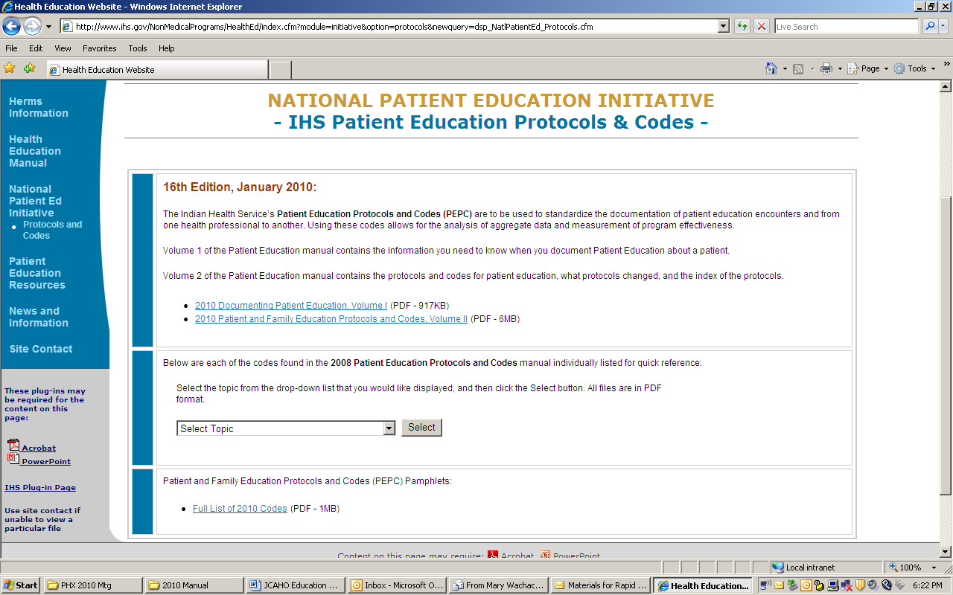
New 2008 Protocols and Codes: New 2009 Protocols and Codes:

NEW 2008 PROTOCOLS
ABNG Abuse/neglect adult/child
ASLT: Assault
BITE: Bites, animal/human
CO: Constipation
ENCOP: Encopresis
FOOT: Foot, podiatry
FTT: Failure to thrive
LICE: Head Lice
NOSE: Epistaxis
OBSC: Obesity Childhood
PTSD: Post Traumatic Stress Disorder
RMSF: Rocky Mountain Spotted Fever
SINUS: Sinus Infection
STING: Insect Stings
YEAST: Yeast Infection

NEW 2009 PROTOCOLS:
AMP Amputations
BD Biopolar Disorder
COND Conduct Disorder
DISSD Dissociative Disorder
DVV Domestic Violence Victim
DVP Domestic Violence Perpetrator
JRA Juvenile Rheumatic Arthritis
LYME Lyme Disease
OCC Obsessive Compulsive Disorder
OCD Oppositional Defiant Disorder
OSA Obstructive Sleep Apnea
OA Osteoarthritis
PANIC Panic Disorder
PERIO Periodontal Disease
PERSD Personality Disorder
PRK Parkinson Disease
PHOB Phobias
PSYD Psychotic Disorders
RA Rheumatic Arthritis
SCBE Scabies
SNAKE Snake Bite
WNV West Nile Virus

2010 Protocols and Codes

New Clinical Protocols and Codes | New Behavioral Health Protocols and Codes
1. Gout (GOUT) | 1. Impulse Disorders (IMPLS)
2. Enuresis (ENU) | 2. Eating disorders (EAT)
3. Reactive Hypoglycemia (RH) | 3. Adjustment Disorders (ADD)
4. Otitis Externa (OEX) | 4. Somatoform (SOMA)
5. Antibiotic Associated Diarrhea (ABXD) | 5. Separation Anxiety Disorders (SAD)
6. Multidrug-resistant Organisms (MDRO) | 6. Pervasive Development Disorders (PDD)
7. Organ Donation/Transplant (TPLNT) | 7. Learning Disorders (LD)
8. Central Line Catheter (CVC) | 8. Mental Retardation (MR)

2011 Protocols and Codes

New Clinical Protocols and Codes | New Behavioral Health Protocols and Codes
1. Cerebral Palsy (CERE) | 1. Sexual Disorder (SEX)
2. Home IV (IV) | 2. Dementia (DEM)
3. Sycope (Fainting) (SYN) | 3. Factitious Disorders (FD)
4. Renal Calculi/Kidney Stones (STONE) | 4. Sleep Disorders (SLEEP)
5. Muscular Dystrophy (MD) | 5. Delirium (DEL)
6. Pyelonephritis (PYE) | 6. Reactive Attachment Disorder (REACT)
7. Occupational Health (OCC)
8. Electrolyte abnormalities (ELEC)

Proposed new JCAHO Requirements on Health Communications
Issue(s) Addressed | Proposed Requirement(s)
Staff Training on Cultural Sensitivity | HR.01.04.01, EP 5 HR.01.05.03, EP 7 HR.01.05.03, EP 8
Staff and Licensed Independent Practitioner Training on the Use of Communication Tools | HR.01.05.03, EP 9 MS.03.01.03, EP 7
Use of Population-and Patient-Level Demographic Data | LD.04.03.01, EP 4 LD.04.03.01, EP 5
Identification of Patient Communication Needs | PC.0X.0X.0X, EP 1
Address Communication Needs Across the Care Continuum | PC.0X.0X.0X, EP 2
Provision of Language Access Services and Auxiliary Aids | PC.0X.0X.0X, EP 3
Assessment of Patient Understanding | PC.0X.0X.0X, EP 4 PC.02.03.01, EP 25
Inclusion of Health Literacy Needs in Learning Needs Assessment | PC.02.03.01, EP 1
Collection of Patient-Level Demographic Data | RC.02.01.01, EP 1 RC.02.01.01, EP 4
Documentation of the Need for Mobility Assistance | RC.02.01.01, EP 2
Documentation of the Use of Language Access Services and Auxiliary Aids | RC.02.01.01, EP 4
Accommodation of Patients’ Cultural and Personal Beliefs | RI.01.01.01, EP 6
Accommodation of Patients’ Religious and Spiritual Practices | RI.01.01.01, EP 9
Non-Discrimination in Care | RI.01.01.01, EP 11
Inform Patients of Right to Receive Language Access Services | RI.01.01.03, EP 4
Unlimited Access to Designated Patient Advocate | RI.01.02.01, EP 23

Proposed HP2020 Information Technology Objectives

11-1 Increase individuals’ access to the internet.

11-2 Improve the health literacy of the population.

11-3 DROPPED for 2020 (Increase Research/Evaluation)

11-4 Increase the proportion of quality, health-related Web sites.

11-4a Increase the proportion of health-related Web sites that meet three or more evaluation criteria, disclosing information that can be used to assess information reliability; and

11-4b Increase the proportion of health-related Web sites that follow established usability principles.

11-5 DROPPED (Develop Centers of Excellence)

11-6 Increase the proportion of persons who report that their health care providers have satisfactory communication skills.

11-6a Increase the proportion of persons who report that their healthcare provider always listened carefully to them;

11-6b Increase the proportion of persons who report that their healthcare provider always
explained things so they could understand them;

11-6c Increase the proportion of persons who report that their healthcare provider always
showed respect for what they had to say; and

11-6d Increase the proportion of persons who report that their healthcare provider always
spent enough time with them.

(For whatever reason, there is no 11-7, 11-8, 11-9 Objectives)

11-10 Increase the proportion of adults who report having social support.

  - Increase the proportion of crisis and emergency risk messages, intended to protect the public’s health, that demonstrate the use of best practices. (Developmental)

  - Increase the proportion of providers who use health information technology to
Improve individual and population health. (Developmental)

11-13 Increase the proportion of online health information seekers who report easily
accessing health information.

11-14 Increase the proportion of providers and governmental health agencies that use advanced connectivity to optimize electronic health information exchange to improve individual and population

